PROJECT DESIGN PHASE - II

TECHNOLOGY STACK (ARCHITECTURE & STACK)

|  |  |
| --- | --- |
| Date | 25October 2022 |
| Team ID | PNT2022TMID19437 |
| Project Name | Personal Assistance for Seniors Who Are Self-Reliant |

TECHNICAL ARCHITECTURE:

The Deliverable shall include the architectural diagram as below and the information as per the table1 & table 2.

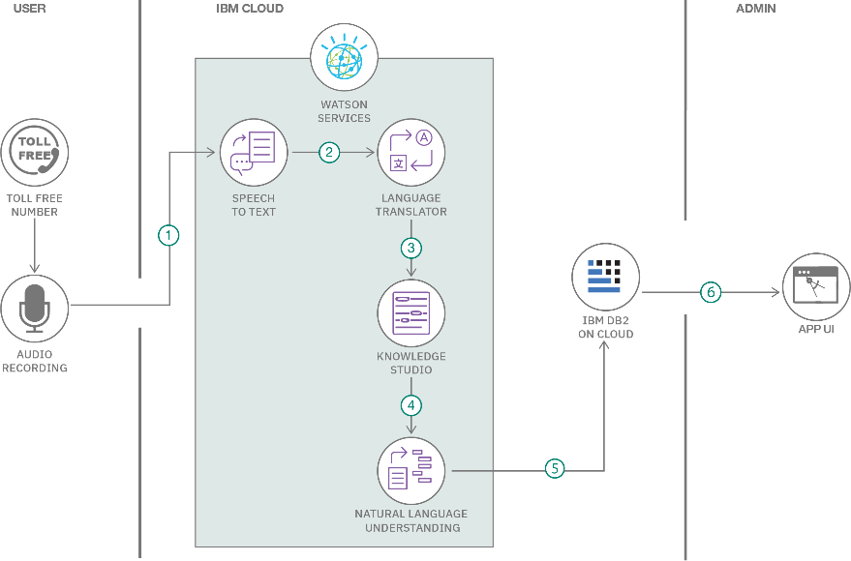

Table-1: Components & Technologies:

|  |  |  |  |
| --- | --- | --- | --- |
| **S.No** | **Component** | **Description** | **Technology** |
| **1.** | User Interface | Mobile App | HTML, CSS, |
|  |  |  | JavaScript |
| **2.** |  |  | Python |
| Application Logic-1 | Mobile App to enter the Medicine  Details weekly |
| **3.** | Application Logic-2 | Gets the medication data from database | IBM Watson IoT API Call data |
| **4.** | Application Logic-3 | Converts the text to speech to pronunciation for the user | IBM Watson Assistant |
| **5.** | Database | Medication time and tablets name on daily and | MySQL |
| **6.** | Cloud Database | Call the data IBM Cloudant is used and user login credentials | IBM DB2, IBM  Cloudant |
| **7.** | File Storage | App code and IoT credentials are stored and API keys | IBM Block Storage |
| **8.** | External API-1 | To get the medicine box status  Open or not | IBM box status API |
| **9.** | External API-2 | To get the login credentials in  IBM DB2 | Username and Password API |
| **10.** | Machine Learning | To convert the text | Text to speech |
|  | Model | into speech for |  |
|  |  | voice command the |  |
|  |  | tablet details |  |
| **11.** | Infrastructure (Server / Cloud) | To host the server and application | Cloud Foundry, Node Red |

Table-2: Application Characteristics:

|  |  |  |  |
| --- | --- | --- | --- |
| **S.N**  **o** | **Characteristics** | **Description** | **Technology** |
| **1.** | Open-Source Frameworks | To develop the application interface, we use  **MIT App Inventor** | MIT APP INVENTOR |
| **2.** | Security Implementations | To secure the users login credentials and personal information | SHA-256, OWASP |
| **3.** | Scalable Architecture | To scale the application database | IBM Auto scaling |
| **4.** | Availability | To make use the application and data are available 24/7 | IBM Cloud load balancer |
| **5.** | Performance | To increase the performance the application in hosted in the high- performance instance | IBM instance |